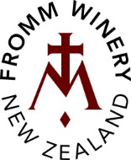
FROMM Sauvignon Blanc 2020
Fromm Winery
15 Godfrey Road, RD 2
Blenheim 7272
New Zealand

Phone +64 (0)3 572 9355
Fax +64 (0)3 572 9366

info@frommwinery.co.nz
www.frommwinery.co.nz

Grape variety | 100% Sauvignon Blanc
Bottled | September 2020
Cellaring potential | 2024
Winemaker | Hätsch Kalberer
Wine analysis | Alcohol | 13.5 %
 | Total acidity | 6.1 g/l
 | pH | 3.05
 | Residual sugar | less than 1 g/l
 | 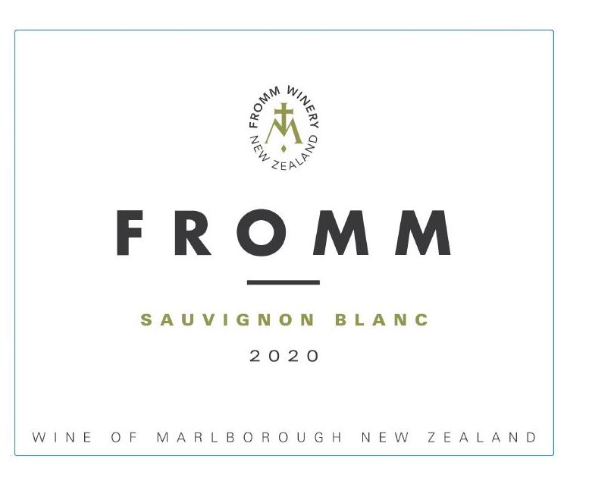
Comment | This Sauvignon Blanc is made from grapes grown in the elevated Churton Vineyard in Marlborough’s Waihopai Valley. 100% handpicked, whole bunch pressed and fermented in stainless steel tanks, this wine is bone-dry with moderate weight and acidity yet a firm structure to give it a more textural and subtle mouthfeel. As the wine opens up in the glass, it reveals a nice balance of ripe fruit with a touch of flintstone minerality and a delicate phenolic lift in the finish, making it an excellent food wine.

